A Large-scale Outbreak of Botulism Associated with a Traditional Celebratory Egyptian Fish Dish in Five Governorates – Lower Egypt, 2019: A Teaching Case-study

Authors
Sherif Shamseldein^{1,2}, Mahmoud Azqul^{1,2}, Sahar Samy^{1,2}, Hanem Abdelraoof ²

Affiliations
¹ Egypt Field Epidemiology Training Program (FETP)
² Ministry of Health and Population, Egypt

Corresponding author
Sherif Shamseldein (MBBCh, FETP)
National Coordinator of the Rapid Response Team
Ministry of Health and Population, Cairo,
Egypt
Email: dr.sherif.mostafa@gmail.com

Abstract

Botulism is a potentially fatal illness caused by the botulinum toxin. Foodborne Botulism is characterized by symmetric descending paralysis of voluntary muscles that can progress to respiratory failure and death. On September 24, 2019, a large Botulism outbreak of 92 cases took place in five governorates in Lower Egypt and was associated with a traditional meal (Feseekh). Feseekh is celebratory Egyptian dish consisting of fermented salted fish that is kept under anaerobic conditions for a long period of time. Case series study was conducted with the sensitive case definition of anyone having neurological or gastrointestinal symptoms and a history of eating Feseekh in the last 10 days.
The goal of this case study is to build the capacity of trainees in investigating outbreaks. This case study stimulates students to analyse surveillance data, critically appraise an epidemic report, and assess the epidemic contingency plan. The case study is designed for training Novice field epidemiology trainees and can be administered in 3-4 hours. Used as adjunct training material, the case study provides the trainees with competencies in analysing available data in order to identify triggering factors for Botulism outbreaks in Egypt and using information to develop a risk map using relevant software.

Keywords: Botulism, outbreak, Egypt

How to Use the Case Study
General instructions: This case study should be used as adjunct training material for novice epidemiology trainees to reinforce the concepts taught in prior lectures. The case study is ideally taught by a facilitator in groups of about 20 participants. Participants are to take turns reading the case study, usually a paragraph per student. The facilitator guides the discussion on possible responses to questions. The facilitator may make use of flip charts to illustrate certain points. Additional instructor’s notes for facilitation are coupled with each question in the instructor’s guide to aid facilitation.

Audience: This case study was developed for novice field epidemiology students. These participants are commonly health care workers working in the county departments of health whose background may be as medical doctors, nurses, environmental health officers or laboratory scientists who work in public health-related fields. Most have a health science or biology background.

Prerequisites: Before using this case study, participants should have received lectures on disease surveillance and outbreak investigation.

Materials needed: Flash drive, flip charts, markers, computers with MS Excel

Level of training and associated public health activity: Novice – Outbreak Investigation

Time required: 3-4 hours

Language: English

Goal of Case Study
The goal of this case study is to build the capacity of trainees in investigating outbreaks.

Learning Objectives
At the conclusion of the teaching session, participants will be able to:

- Define the terms epidemic and outbreak
- Describe the major decisions that need to be addressed before beginning a field investigation
- Develop a case definition for an outbreak investigation
- Interpret data provided in tables and charts
- Communicate study results and their implications to public health decision-makers
Introduction

Botulism is a rare but serious illness caused by a toxin that is made by Clostridium botulinum and sometimes Clostridium butyricum and Clostridium baratii bacteria [1]. This toxin blocks cholinergic neuromuscular junctions, resulting in a characteristic syndrome of symmetric cranial nerve palsies followed, to a varying extent, by symmetric descending paralysis of voluntary muscle that can progress to respiratory failure and death [2].
The bacteria that make the Botulinum toxin are found naturally in many places, but it is rarely cause illness in people. These bacteria make spores which act like protective coatings and help the bacteria survive in the environment, even in extreme conditions. The spores usually do not cause people to become sick, even when ingested. But under certain conditions, these spores can grow and make one of the most lethal toxins known [3] to mankind.
A meal called Feseekh is a traditional Egyptian fish preserve made from fermented, salted, and dried gray mullet; a saltwater fish that lives in both the Mediterranean and the Red Sea. The traditional process of preparing Feseekh is to dry the fish under the sun before preserving it in salt. The process of making this dish is quite elaborated, with the production techniques passed from father to son in certain families. The occupation of making Feseekh has a special name in Egypt: Fasakhani.

Egypt is located in the northeast corner of Africa and is bordered to the west by Libya, to the south by Sudan, to the east by the Red Sea, and to the north the Mediterranean (Figure 1).
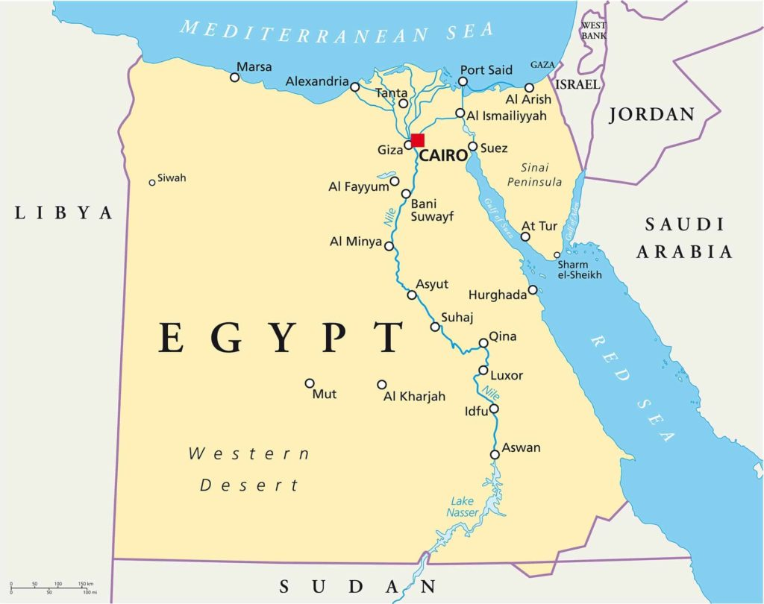

Figure 1. Map of Egypt and Neighboring Countries

Egypt ranks as the highest Arab country in terms of population density. The total area of ​​the country is approximately one million square kilometers, however, only 7.7% of its area is populated, and the populated areas are concentrated in the Delta and Nile Valley.
Egypt is divided administratively into 27 governorates, four of which are urban governorates (Cairo, Alexandria, Port Said, and Suez). The twenty-three other governorates are divided into urban and rural areas: nine are in Lower Egypt, nine in Upper Egypt, and five are border provinces.
Salted fish (Feseekh) is considered a major industry in the Delta region, especially in Kafr Elsheikh and the Behira governorates (Figure 2).

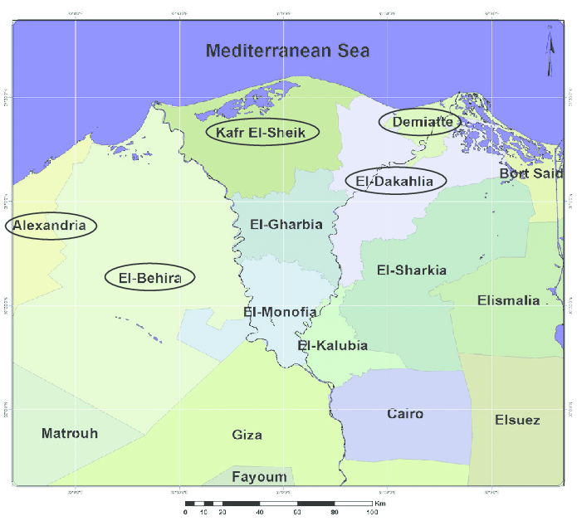
Figure 2. The Delta Region of Egypt

Part 1 Story

On September 24th, 2019 the emergency department at the Ministry of Health and Population (MOHP) was notified by a local health officer from the Alexandria governorate about a case admitted to toxicology center’s ICU with symptoms of abdominal pain, diarrhea, dysphagia, and dyspnea after consuming homemade Feseekh. Next day, several cases were reported from five different governorates all displaying the same symptoms after eating Feseekh from different sources. Most of the cases were admitted to the ICU in toxicology centers and two cases died.

Part 1 Questions

Question 1. Would you call this situation an epidemic or an outbreak? Justify your answer.
Question 2. What should be the objectives of the investigation into the reported cases?
Question 3. Before going to the field, what other preparations and decisions should be made regarding the investigative team’s composition, role, responsibilities?
Question 4. What is the differential diagnosis for the reported cases?

Part 2 Methods

The central rapid response team immediately moved to the Alexandria and Behira governorates to conduct field investigations with the help of peripheral teams. A sensitive case definition was developed to find and line list all cases. Suspected cases were interviewed in the toxicology centers and general hospitals using a semi-structured questionnaire to collect data.

Part 2 Questions

Question 5. What clinical and epidemiologic information could be of importance in the investigation?
Question 6. What components should you include in the case definition? Develop a case definition for this event?
Question 7. How would you search for additional cases?

By the next week, several cases were reported from other governorates. Investigation teams reached cases and carried out contact tracing. Investigations pointed towards certain private fish farms as the source of the outbreak. Farm products were traced in governorates and found that dead fish were sold in the market at very low prices.

Question 8. According to the above information, what should be your next step?
Question 9. What samples would you recommend being collected and tested by laboratory technicians?

Blood specimens from suspected cases were collected and sent to the central laboratories in Cairo for testing. Environmental samples such as food and water supply from private fish farm, markets and the patients’ homes were collected. Samples from street vendors were also collected for laboratory testing. Public health professionals conducted community workshops to increase overall awareness about the hazards of eating Feseekh from unknown or untrustworthy sources.

Part 3: Results

After compiling a line list for all cases, the collected data was cleaned, tabulated, and analyzed using SPSS software. Among the 374 persons who ate Feseekh, 92 (24.6%) developed symptoms of Botulism. Patients' median age was 24 years [IQR: 13-40], and 65 (70.7%) were females. From all patients, 85 (92.4%) consumed homemade Feseekh. Neurological symptoms were reported in 24 (26.1%) patients, and gastrointestinal in 35 (38.0%) patients, while 33 (35.9%) had displayed both symptoms.
Among all suspected patients, 43 (46.8%) recovered spontaneously with no treatment and 49 (53.2%) required treatment using the botulinum antitoxin. Of those treated with antitoxin (47) recovered and 2 died.
From the 35 serum samples tested, 17 (48.6%) were positive for Botulism, and from the 5 food samples tested, 2 (40.0%) were positive for botulism.

Part 3 Questions

Question 10. What other result should have been illustrated?
Question 11. What kind of graph should be used to present the male-to-female ratio?
Question 12. Using the data from the following table, please complete the missing column then present the data in a suitable graph.
Table 1. Number of cases in each governorate
Governorate | Number of Cases | Percentage
Kafr Elsheikh | 40
Alexandria | 24
Behira | 22
Sharkya | 4
Gharbeya | 2
Totals | 92

Question 13. Draw an Epi-curve using the data below. What type of an epidemic curve is it?

Table 2. Number of cases in each date.
Date | Frequency | Percentage
25-09-2019 | 3 | 3.3
26-09-2019 | 1 | 1.1
27-09-2019 | 2 | 2.2
28-09-2019 | 9 | 9.8
29-09-2019 | 14 | 15.2
30-09-2019 | 10 | 10.9
01-10-2019 | 10 | 10.9
02-10-2019 | 2 | 2.2
03-10-2019 | 5 | 5.4
04-10-2019 | 6 | 6.5
05-10-2019 | 4 | 4.3
06-10-2019 | 7 | 7.6
07-10-2019 | 5 | 5.4
08-10-2019 | 1 | 1.1
09-10-2019 | 3 | 3.3
10-10-2019 | 2 | 2.2
12-10-2019 | 3 | 3.3
13-10-2019 | 2 | 2.2
19-10-2019 | 1 | 1.1
20-10-2019 | 1 | 1.1
25-10-2019 | 1 | 1.1
Total | 92 | 100%

Part 4: Discussion

The Egyptian celebration of the Sham El-Neseem national holiday in April is marked by eating Feseekh, and every year, botulism cases are expected at this time of the year. This outbreak arrived on a surprisingly unusual time in September. Investigation revealed that the death of large number of fishs in a private fish farm and their illegal selling in markets were behind this large outbreak. Most of the Botulism cases had consumed homemade fish had bought from untrustworthy sources.

Part 4 Questions

Question 14. What are steps for outbreak investigation?
Question 15. What type of surveillance should be used to ensure that there are no new cases of Botulism?

Part 5: Conclusion

After reading the draft epidemic report and summarizing its findings using descriptive epidemiology, the investigating team concluded that health education, increased community awareness, and facilitated provision of the Botulism anti-toxin for critical cases were crucial to control future outbreaks and decrease mortalities.

Part 5 Questions

Question 16. Which other partners could you contact and involve to help in implementing prevention and control measures?

Acknowledgements

We wish to acknowledge the Eastern Mediterranean Public Health Network (EMPHNET) for their support to develop this case study.

References

- CDC. Botulism Webpage. Last reviewed October 2018. Available at:
https://www.cdc.gov/botulism/general.html
2. Weber, J. T. et al. A Massive Outbreak of Type E Botulism Associated with Traditional Salted Fish in Cairo Published by : Oxford University Press Stable URL : https://www.jstor.org/stable/30113098 Fish in Cairo A Massive Outbreak of Type E Botulism Associated with Traditiona. 167, 451–454 (2020).
3. Botulism in Alaska – November 2017: http://dhss.alaska.gov/dph/Epi/id/SiteAssets/Pages/botulism/monograph.pdf

